DETAILED DESIGN DOCUMENT
Distributed Multi-Robot Tracking Handoff System
Sections 1 & 2 — Data & Communication Protocol / Negotiation & Decision Logic
Detailed Design Phase — R&D Blueprint
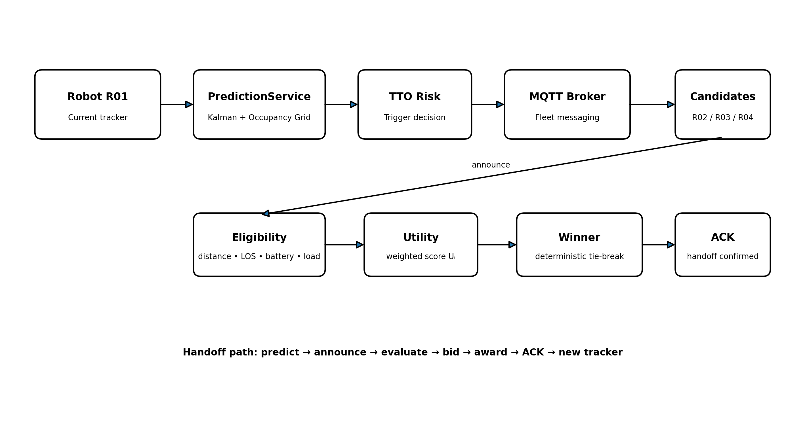
Figure 1. High-level decentralized handoff architecture.

SECTION 1 — Data & Communication Protocol

1.1 MQTT Topic Taxonomy
A scalable topic space separates traffic by function first, then entity, then stream. This allows clean subscriptions and class-specific QoS policies.
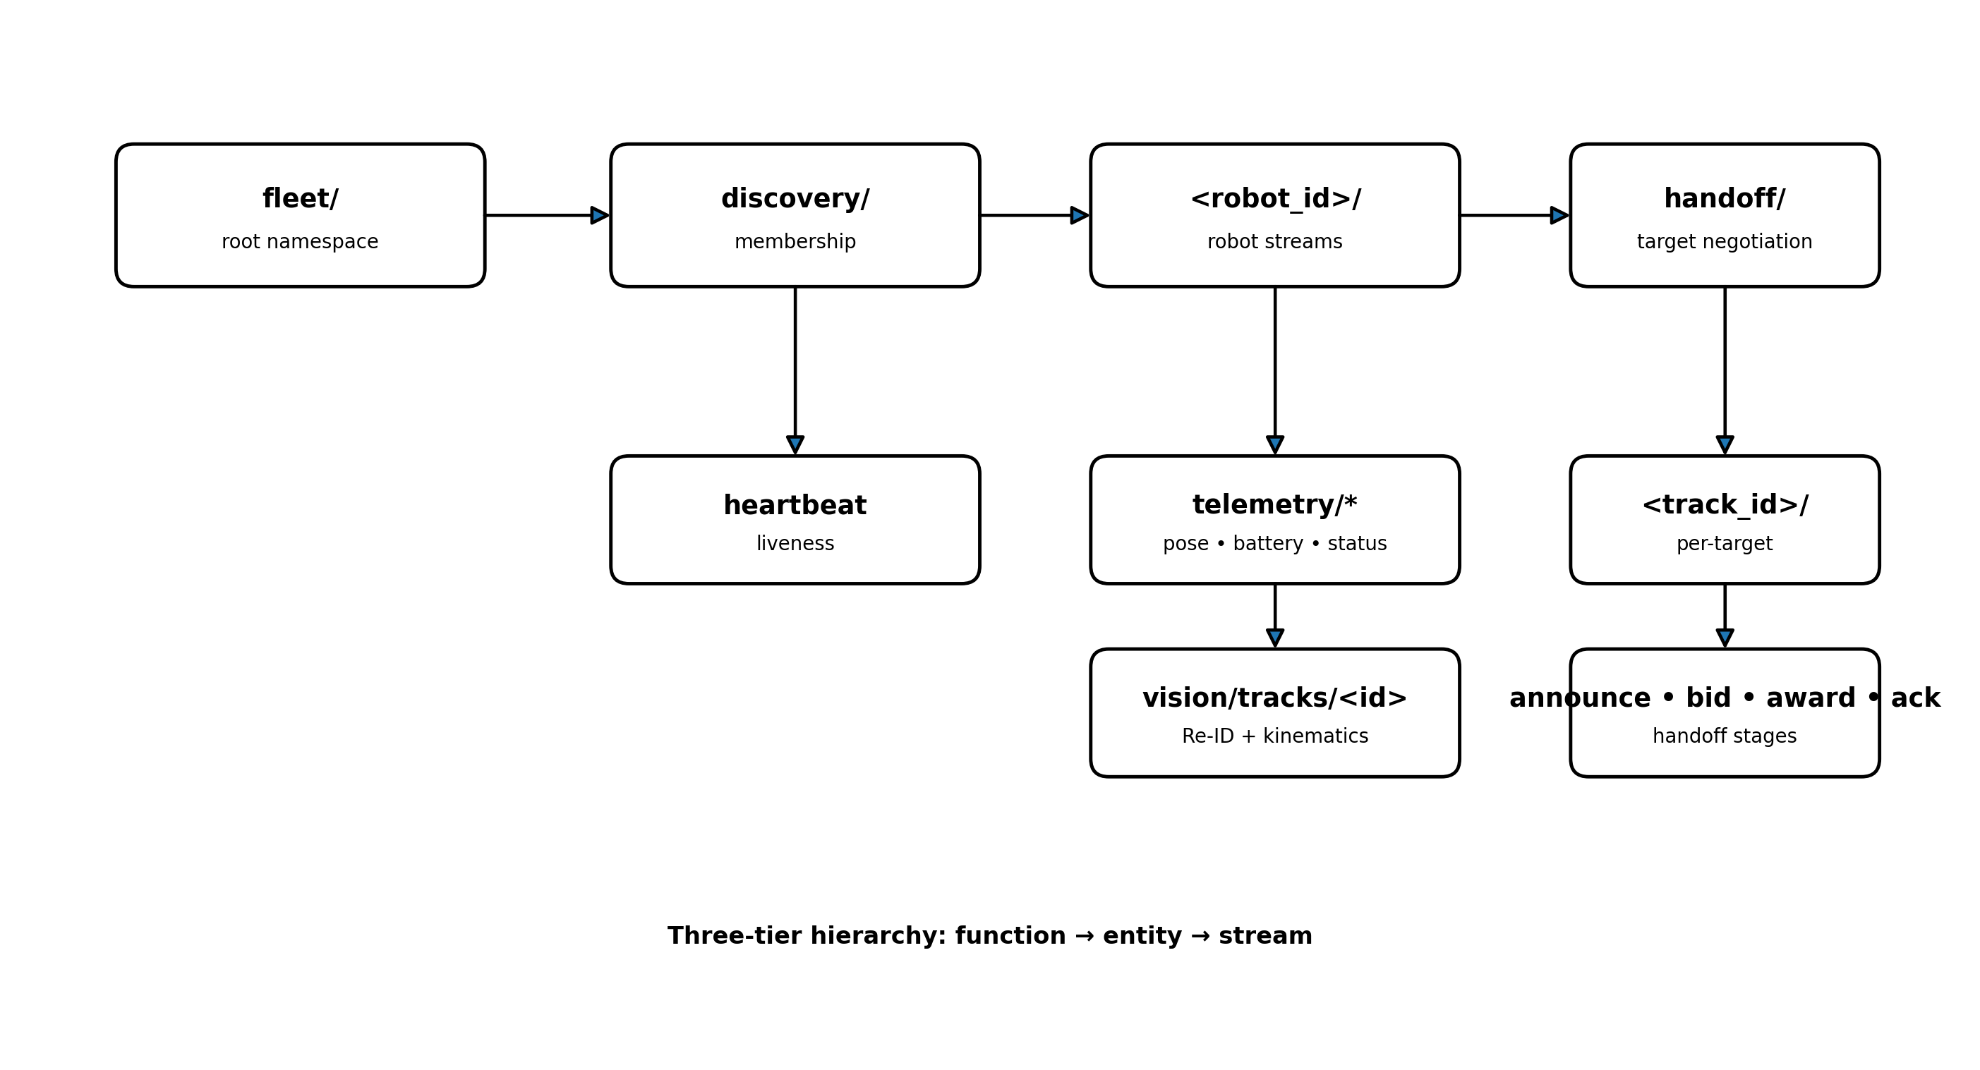
Figure 2. Proposed three-tier MQTT topic hierarchy.

Proposed Topic Structure
fleet/
├── discovery/
│ └── heartbeat
├── <robot_id>/
│ ├── telemetry/
│ │ ├── pose
│ │ ├── battery
│ │ └── status
│ └── vision/
│ └── tracks/<track_id>
└── handoff/
└── <track_id>/
├── announce
├── bid
├── award
└── ack
Key design choice: negotiation topics are keyed by track_id, enabling a robot to subscribe only to relevant target negotiations instead of fleet-wide chatter.

Topic Classes & QoS
Topic class | QoS | Retained | Purpose
telemetry/pose, telemetry/battery | 0 | No | High-frequency latest-state data
vision/tracks/* | 1 | No | Track metadata; duplicates tolerated
handoff/*/announce, bid | 1 | No | Negotiation messages
handoff/*/award | 2 | Yes (short TTL) | Critical winner declaration
discovery/heartbeat | 0 | Yes | Latest fleet liveness snapshot

1.2 Lean JSON Payload Schema
The dominant payload cost is the 128-dimensional Re-ID embedding. Quantizing the vector to INT8 reduces its raw size to 128 bytes, while short keys reduce repeated field-name overhead.
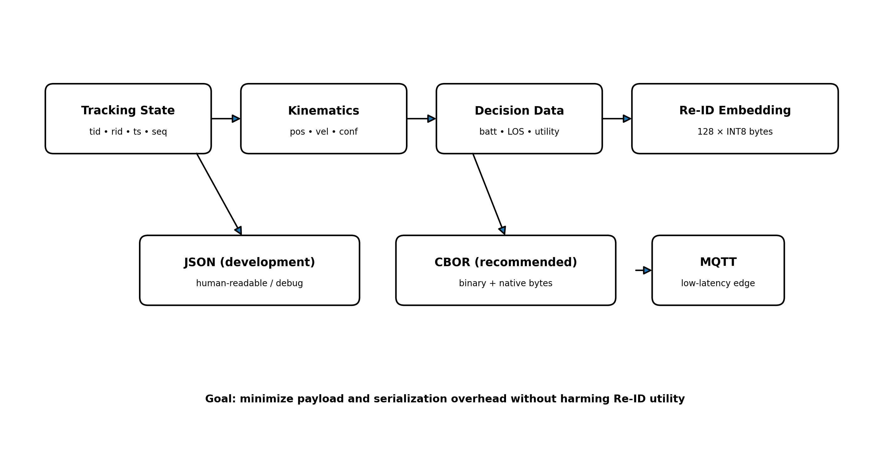
Figure 3. Lean payload composition and serialization path.

Proposed Bid Payload
{
"tid": 17,
"rid": "R04",
"ts": 1893456213,
"seq": 42,
"pos": [12.4, 5.1],
"vel": [0.8, -0.2],
"conf": 0.91,
"batt": 0.63,
"los": 0.78,
"u": 0.712,
"reid": "b64:qk3F...=="
}

Re-ID Quantization
q_i = round(v_i × 127), q_i ∈ [-127, 127]
v_i ≈ q_i / 127
Size comparison: float64 ≈ 1024 bytes; float32 ≈ 512 bytes; INT8 = 128 bytes for the 128-dimensional vector.

1.3 Serialization & Compression Strategy
Option | Approx. payload | Decision
JSON, float64 + verbose keys | ~2,600 B | Baseline — rejected
JSON, INT8 Re-ID via base64 | ~330 B | Fallback
CBOR, native byte-string | ~155 B | Recommended
Protobuf | ~150 B | Future option after schema freeze
MessagePack | ~150 B | Comparable; CBOR preferred
Recommendation: use CBOR for latency-critical handoff and track payloads during the simulation phase, with a possible migration to Protobuf once the message contract becomes stable.
General-purpose compression is not recommended for the INT8 Re-ID vector itself because the quantized embedding is effectively noise-like for deflate-style compressors; compression remains useful for batched telemetry.

SECTION 2 — Negotiation & Decision Logic (NegotiationSERVICE)
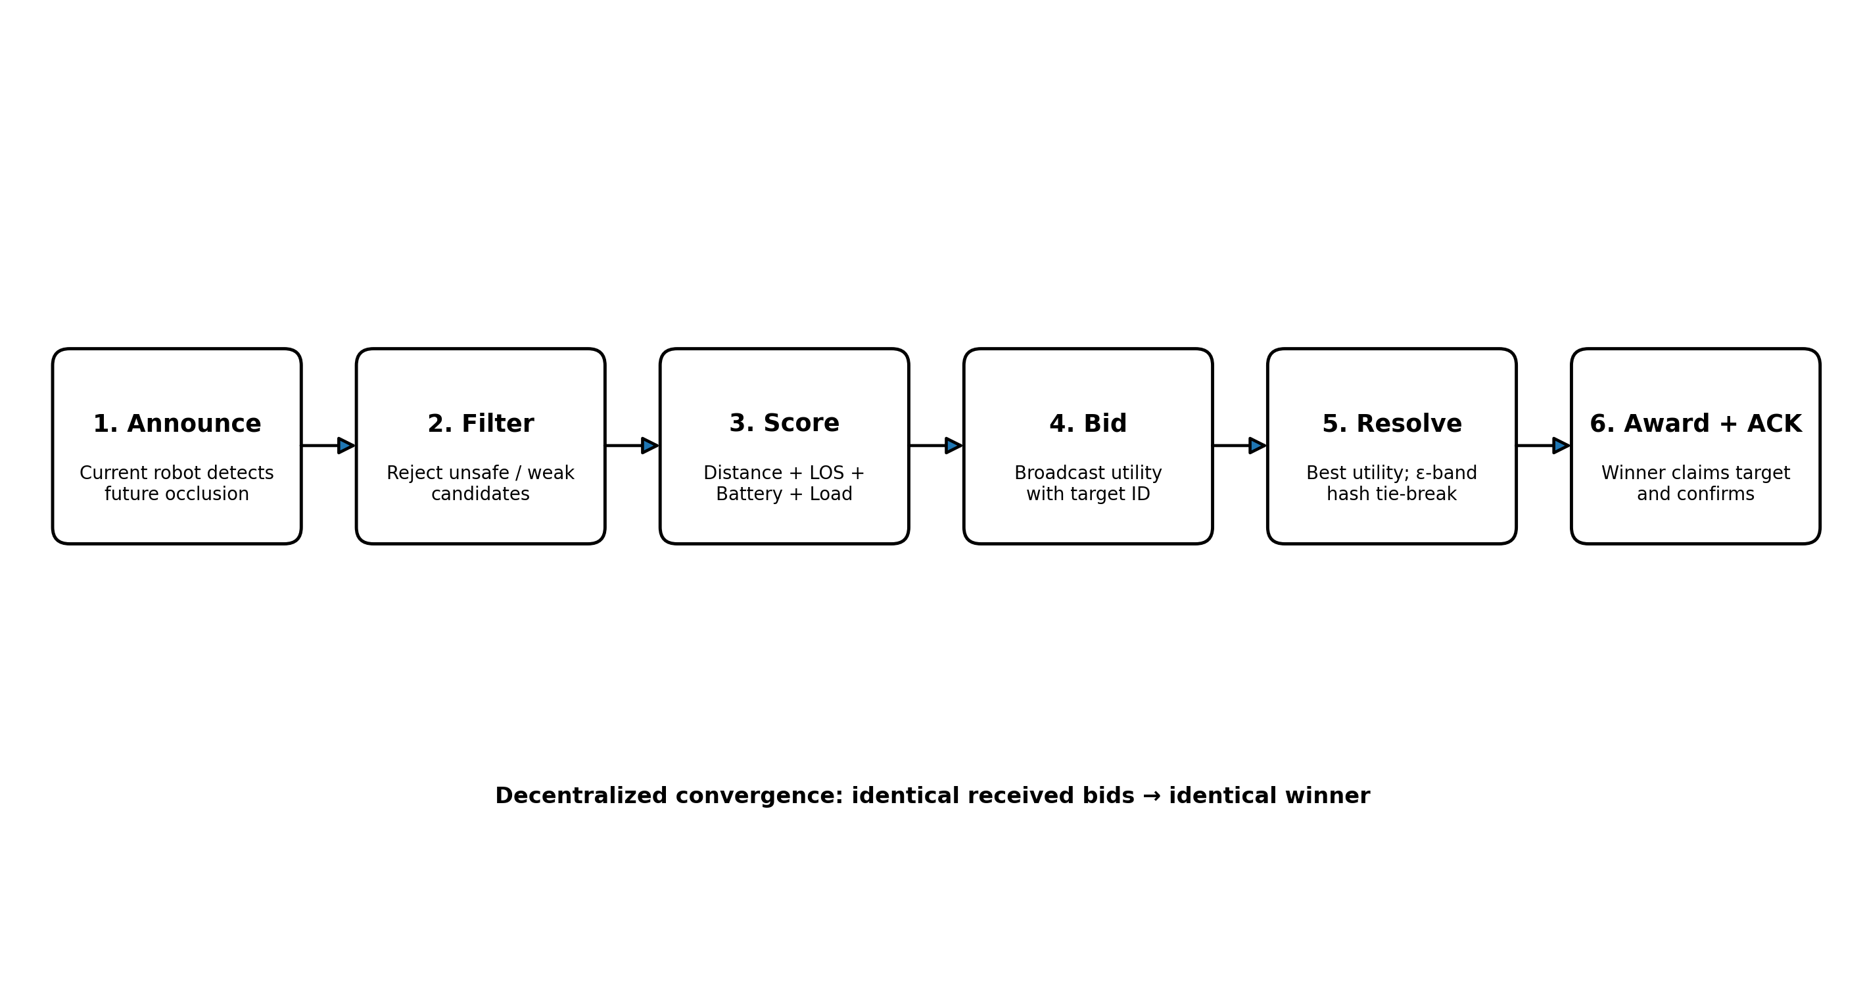
Figure 4. Decentralized negotiation and winner-selection flow.

2.1 Utility Score Cost Function
The utility score is a single scalar in [0,1] that ranks candidate robots using normalized distance, line-of-sight probability, battery condition, and current tracking load.
U_i = w1 · f_dist(d_i) + w2 · f_los(p_i) + w3 · f_batt(b_i) + w4 · f_load(n_i)
subject to: w1 + w2 + w3 + w4 = 1, U_i ∈ [0, 1]

Component Functions
d_i = || p_robot_i − p_target(t + Δt_negotiation) ||₂
f_dist(d_i) = max(0, 1 − d_i / d_max)
f_los(p_i) = p_i, p_i ∈ [0,1]
f_batt(b_i) = b_i^γ, γ > 1 (e.g., γ = 2)
f_load(n_i) = 1 − (n_i / n_max)
The distance is computed to the target's predicted position at handoff time rather than its current position, accounting for target motion during negotiation latency.

Proposed Initial Weights
Term | Weight | Rationale
Distance (w1) | 0.35 | Strong predictor of reacquisition and sustained tracking
LOS (w2) | 0.30 | Core objective of proactive handoff
Battery (w3) | 0.20 | Operational reliability; shaped non-linearly
Load (w4) | 0.15 | Prevents overloading already-busy robots
These values are engineering starting points, not experimentally proven optima. They should be exposed as runtime parameters and tuned using simulation-based sensitivity analysis.

2.2 Decentralized Tie-Breaking Mechanism
Because utility values are quantized and near-equal scores are possible, the system uses an epsilon-band followed by a deterministic hash-based secondary key.
1) If |U_i − U_j| ≤ ε, treat the scores as tied (e.g., ε = 0.01).
2) key_i = hash(track_id ⊕ robot_id ⊕ seq)
3) winner = argmin_i key_i
Hash-based tie-breaking avoids systematically favoring the same low-numbered robot and distributes tie wins across the fleet.

Convergence Rule
- Candidates subscribe to handoff/<track_id>/bid for a fixed T_negotiate window.
- Each candidate maintains the best (utility, key) tuple observed, including its own bid.
- If its own bid remains best when the window closes, it publishes the award.
- Other candidates stop bidding and the winner publishes ACK.
- If no award is observed, candidates re-derive the winner locally and re-announce as a self-healing safety net.

Design Validation Priorities
Area | Metrics / experiments
Communication | Payload size, serialization latency, MQTT end-to-end latency, packet loss
Negotiation | Decision latency, winner consistency, message count, failure recovery
Prediction integration | TTO error, occlusion detection accuracy, trigger latency
End-to-end handoff | Success rate, target ID consistency, tracking interruption duration

Next Steps
- Validate the schema against the ROS 2 ↔ MQTT bridge selected for the Gazebo testbed.
- Run sensitivity sweeps for w1…w4, T_negotiate, T_jitter, and the epsilon tie threshold.
- Benchmark JSON versus CBOR under realistic wireless payload and latency conditions.
- Integrate the negotiation flow with the trajectory/occlusion PredictionSERVICE and Level-1 Gazebo scenarios.

